# Inquiry Lesson Plan 4

|  |  |  |  |  |  |
| --- | --- | --- | --- | --- | --- |
| **Lesson Title:** | Significant factors of Global Warming | **Lesson:** | 4 | **Date:** | 3 April, 2021 |
| Name: | Nidhi Saini(T00671429) | Subject(s): | Environme-ntal Education | Grade(s): | 7th |

Inquiry Project Rationale & Overview

|  |
| --- |
| **Why does this topic matter to students?**  Studies have stated that the recent IPCC special reports have provided certain alarming facts that depict global warming has been accelerating (Xu, Ramanathan& Victor, 2018). Thus, it is the responsibility of the teachers to provide relevant information regarding the impact and causes of global warming through this lesson of the workshop and allowing younger minds to contemplate on the issue and participate in the protection of the environment through implementing proper practices. This will also create awareness among the students so that they can further educate their families to adopt these measures.  **How does this project incorporate the inquiry cycle?**  The lesson will address the ask, investigate and discussion parts of the inquiry cycle to allow the students in engaging themselves to understand the causes, factors and significant impact of global warming with the help of their teachers and contribute to the learning process through an open discussion where their queries and doubts will be cleared. |

Key Questions For Inquiry About the Topic of Study

|  |  |
| --- | --- |
| Core Question | Supporting Questions |
| * What are the causes of global warming? * What are the significant factors that elevate global warming? * What are the impacts of global warming? | * Are there any queries regarding the topic? |

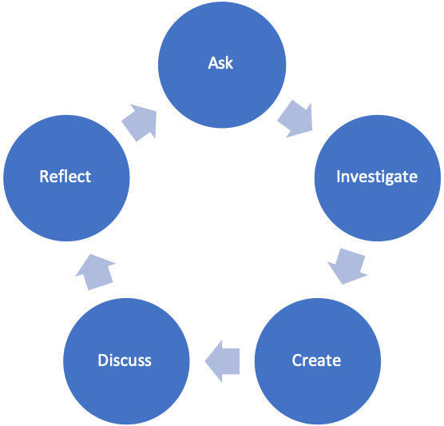

**Inquiry Approach/Style and Rationale**

|  |
| --- |
| The inquiry based learning approach has been considered through which the students will be thoroughly helped to understand the core concept of global warming and its impacts on the environment and the students will be encouraged to participate in open discussions so that they can evaluate the topic, apply their decision making and creative problem solving skills to derive possible solutions. |

Core Principles of Effective Teaching (Sharon Friesen)

|  |  |
| --- | --- |
| **Core Principle 1:** Effective teaching practice begins with the thoughtful and intentional design of learning that engages students intellectually and academically.  *\*\*How is the inquiry focused on building disciplinary knowledge and understandings?* | In the present times, expertise in the field of science is a necessity but not a luxury (Mostafa, Echazarra&Guillou, 2018). Therefore it is the role of the teacher to embed the core concept in the students so that they engage in thinking on their own. |
| **Core Principle 2:** The work that students are asked to undertake is worthy of their time and attention, is personally relevant, and deeply connected to the world in which they live.  *\*What makes this inquiry valuable, meaningful, and “alive” for the students and teachers?* | The use of relevant materials and resources will help in attracting the attention of the students and connect them with the theoretical as well as practical approach to the causes and impacts of global warming and identifying the significant factors for further evaluation. |
| **Core Principle 3:** Assessment practices are clearly focused on improving student learning and guiding teaching decisions and actions.  *\*How do I define learning and success in this inquiry? How is learning expressed and articulated in peer, self and teacher assessments?* | The learning and success of the inquiry will depend on the ability of the teacher to provide adequate support and guidance to the students and enhance their knowledge regarding the factors of global warming and helping them to contribute to the cause. |
| **Core Principle 4:** Teachers foster a variety of interdependent relationships in classrooms that promote learning and create a strong culture around learning.  *\*How do I connect students with each other, with experts in the field, with larger communities and nature, and across disciplines?* | Creating an environment that supports a strong learning culture will help the students in opening up in front of their teachers and participating in the discussions about the topic thus building a relationship of trust which will promote further learning. |
| **Core Principle 5:** Teachers improve their practice in the company of peers.  *\*How do I reflect on the inquiry together, and/or collaborate with others?* | Teaching practice can be successfully improved through increased interaction with peers and engaging in collaborative learning. This can be achieved by including different teachers in the group discussion about the topic where each can contribute their expertise and knowledge resulting in an improved learning session. |

BC Curriculum Core Competencies

|  |  |  |
| --- | --- | --- |
| Communication | Thinking | Personal & Social |
| * Adaptation and application of the effective communication patterns. | * Application of the thinking skills such as observation, analysis, interpretation and decision making. | * Effectively handling student interactions and maintaining a strong relationship with them. |

BC Curriculum Big Ideas (STUDENTS UNDERSTAND)

|  |
| --- |
| Global warming plays an important role in climate change and adversely affects the environment and so it is necessary to learn about the significant factors that cause global warming. |

BC Curriculum Learning Standards

|  |  |
| --- | --- |
| **(STUDENTS DO)** | **(STUDENTS KNOW)** |
| Learning Standards - Curricular Competencies | Learning Standards - Content |
| * Encouraging students to participate in open discussion with the teachers. | * Engaging in the doubt clearing session for the students. |

Indigenous Connections/ First Peoples Principles of Learning

|  |
| --- |
| *How will I incorporate Indigenous knowledge and principles of learning?*  Indigenous knowledge can be considered as a process that has to be absorbed and understood (Magni, 2017). The students will be allowed to express their views on the topic through an open discussion so that they can think over the topic and present their views. |

Respectful Relations

|  |
| --- |
| *How will I invite students of all backgrounds, interests and skills into the inquiry?*  As teachers, it is important to build strong relationships with each and every student so that they can trust and speak their minds in front of the teachers. This will help in encouraging every student to participate and show interest in the topic. |

Project Overview

|  |  |  |  |
| --- | --- | --- | --- |
| Time Estimate | | Teacher and Student Activities | Assessment Activities |
| Ask | 1 hour | The students will be asked about the lessons learnt in the previous days of the workshop to recollect the core concept regarding the topic. | Recollection through direct question and answers. |
| Investigate | 1 hour | The students will be informed regarding the significant factors of global warming through video presentations so that they can remember the factors for further learning. | Video presentation demonstration |
| Create | 3 hours | The students will be engaged through the demonstration of an experiment which will help them in learning the possible factors and impact of global warming. | Demonstrating experiment for student learning. |
| Discuss | 2 hours | The students will be encouraged to participate in the open discussion on the topic and mitigation of the issue and their views will be considered to understand what they have inculcated through the workshop. | Open discussion on the topic. |
| Reflect | 1 hour | The students will be asked to prepare a logbook for reflecting on their learning process throughout the entire workshop and present discussion on that. | Writing a reflective piece and maintaining a log book. |

Materials and Resources (use APA citation format)

|  |
| --- |
| Video presentations, experiment demonstration, log books, study materials, animated posters and cliparts. |

Organizational Strategies (Optional)

|  |
| --- |
| The students need to be provided with a clear concept regarding the significant factors of global warming so that they are able to understand the impact of the process on the environment for taking the necessary measures that can control the situation. Students need to be encouraged to contribute to the life and work of schools and should be taught from younger ages to exercise their responsibilities as community members (Jabbarova, 2020). |

Proactive, Positive Classroom Learning Environment Strategies (Optional)

|  |
| --- |
| Promotion of the educational learning environment in the workshop will help in maintaining a strong learning culture among the students. |

Extensions

|  |
| --- |
| The log book can be used as an extension by the students for further contemplating on the topic. |

Reflections (to be completed after Project Completion)

|  |
| --- |
| What did I learn about Inquiry Based Pedagogy?  I learnt about the appropriate problem solving and the importance of emphasizing on the student perspective.  What challenges and successes did I experience?  Clearing the doubts of these younger minds was a challenge and helping these young children to take part in a bigger cause was indeed a success.  What would I adapt for next time?  Better communication skills to break barriers in approaching the students.Innovative teaching involves creative and novel learning changing teaching style and method (Kalyani, &Rajasekaran, 2018).  What questions do I still have about Inquiry Based Pedagogy?  The idea that inquiry based pedagogy involves direct instructions from the teachers to the students is still not clear. |

**References**

Jabbarova, A. (2020). PLANNING TEACHING AND LEARNING ON THE BASE OF CURRICULUM DESIGN AND DEVELOPMENT. *АрхивНаучныхПубликаций JSPI*, 1-5.

Kalyani, D., &Rajasekaran, K. (2018). Innovative teaching and learning. *Journal of applied and advanced research*, *3*(1), 23-25.

Magni, G. (2017). Indigenous knowledge and implications for the sustainable development agenda. *European Journal of Education*, *52*(4), 437-447.

Mostafa, T., Echazarra, A., &Guillou, H. (2018). The science of teaching science: An exploration of science teaching practices in PISA 2015.

Xu, Y., Ramanathan, V., & Victor, D. G. (2018). Global warming will happen faster than we think.